# Setup to Connect to the Database Used by FlightGUI.exe

FlightGUI uses a SQLite database. There may be other solutions, but the following works.

Note: the database on a new, clean NimbusClient only exists within the UFT installation directory. Because of that it is “read-only” and will not reflect any newly created orders. For the following to work, **BEFORE** doing any other steps in this document, launch FlightGUI one time. This will copy the install database into the users appData directory, which is what the ODBC connection **must** use.

If you downloaded the comprehensive repository from github (github: <https://github.com/rsercely/comprehensive-uft-test-flightgui.git> )

the media files necessary to create a SQLite database ODBC connection were also download. If you are doing this “stand alone”, start at this URL: (again – you only have to go to the following URL and download if you did NOT download the repository github)

<http://www.ch-werner.de/sqliteodbc/>

Download both [sqliteodbc.exe](http://www.ch-werner.de/sqliteodbc/sqliteodbc.exe) *and* [sqliteodbc_dl.exe](http://www.ch-werner.de/sqliteodbc/sqliteodbc_dl.exe) as indicated.

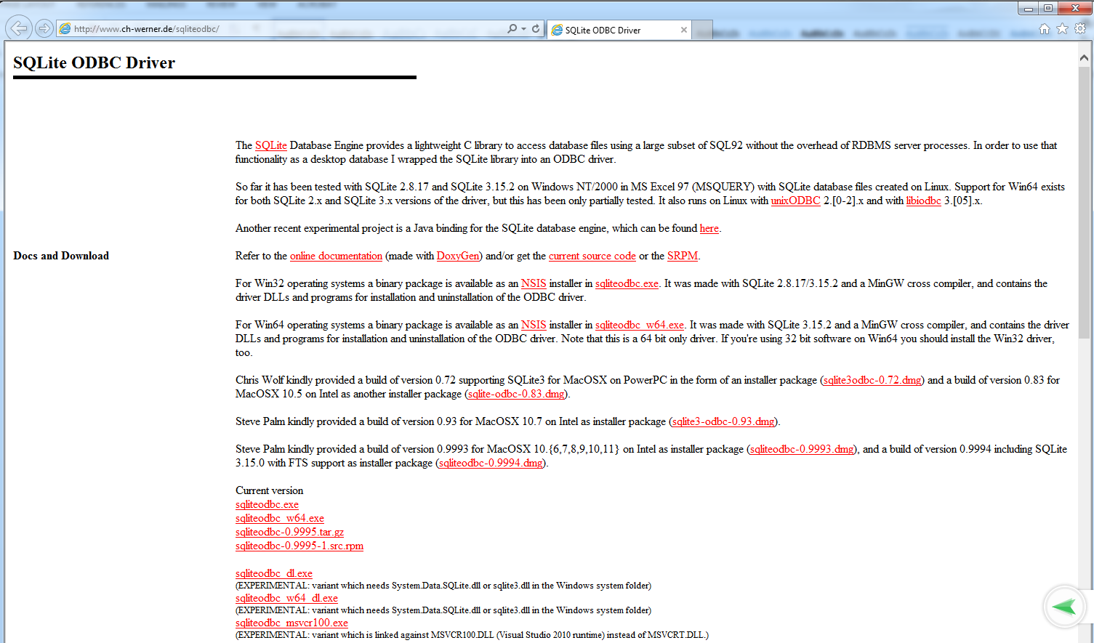

Here is zoomed in view, to make the file names easier to read.



Both files must be placed, and run from the same directory. After placing, **you must run sqliteodbc_dl.exe first, then sqliteodbc.exe.** If you get a warning or error when trying to connect (the next section), just come back and try to install again.

You might want to also download a GUI tool to work with SQLite databases. One possible place is: <https://github.com/sqlitebrowser/sqlitebrowser/releases>

Start the 32-bit ODBC Administrator (run:  %systemdrive%\Windows\SysWoW64\odbcad32.exe)

In the ODBC Data Source Administrator (32-bit) window, click the Add button to add a data source.

The Create New Data Source window appears.

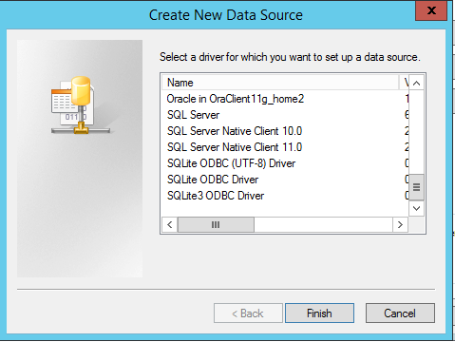

Scroll to the bottom. Choose SQLite3 ODBC Driver, **not** SQLite ODBC Driver (which is the 64-bit driver). Note that the screen shots below were done from a Windows 7 installation, so your screen might look slightly different. If there is a problem with the installation of the ODBC software, you will not see the SQLite options, above. Configure the connection:

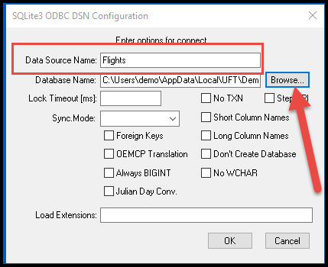

* Note that the Data Source Name is hard coded in the script, so be sure to use exactly the string “Flights” as shown above
* The Database Name is probably

C:\Users\<your login>\AppData\Local\UFT\Demo\DB\Flights.s3db

But you should use the Browse control to verify

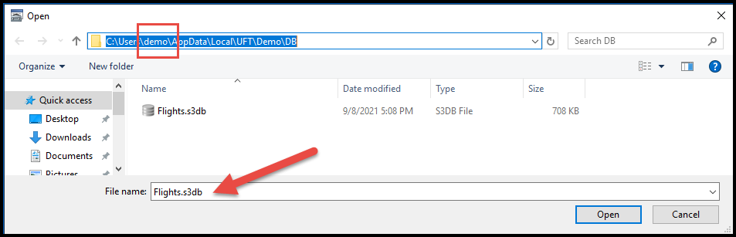

Just to be clear – I have chosen a Data Source Name that matches the name of the actual database file, but this is **not** necessary, it is just a naming convention. However, if you want to use the Comprehensive test – that test uses “hard coded” values of Flights. Because of that, for this Comprehensive test, if you use any other value, when you replay, you will get UFT errors like:

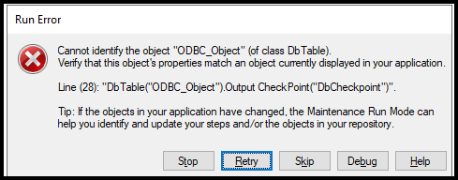

Note – within UFT, if you create a new database checkpoint or output value, within Microsoft Query, you may see:

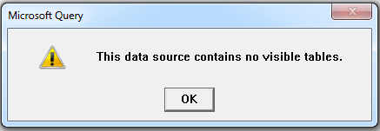

To fix this, hit OK, then select Options…

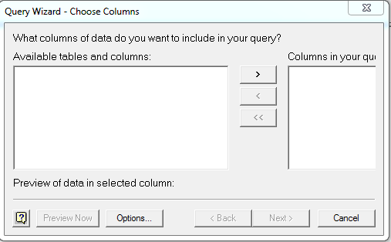

Enable System Tables by clicking the box. If you still don’t see data, you might toggle System Tables a few times.

